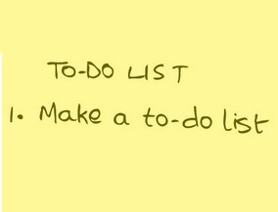Practice-It Review

for Upcoming Recursion Test

Go to the Practice-It website at: <http://practiceit.cs.washington.edu/>.

Create an account if you don’t already have one. The only purpose for creating the account is so that your work is saved when you leave the website. You’ll be able to pick it back up when you log back in. Save your username and password as you will use this website throughout the year. No one at TJ or the University of Washington tracks user information, so you can use whatever you’d like for a username and password.

Once you log in, click on **<Start Practicing!>**.

Select **<Building Java Programs, 4th Edition>**.

Select **<BJP4 Chapter 12: Recursion>**.

Your assignment is to solve ANY two of the exercises 12.1-12.22 (not self-checks). As you complete each assignment (you’ll know you are done when it shows that you passed all tests), print the completed page(s) along with the unit tests. To print, select <CTRL-P>. Write your name on top (if your user name is not obvious) and turn in to me.

For full credit, your two assignments should be turned in on Friday, October 19 before you take the Recursion test.

Note: there is a <Show Solution> button in the upper right hand corner. If you click this button, I will know as it reports it on your page. Don’t do it for the ones you expect to receive credit.

Feel free to do as many exercises or self-checks for practice.

The assignment is worth a total of 6 points (3 points each).

Go to the Practice-It website at: <http://practiceit.cs.washington.edu/>. (Haha, just kidding.)